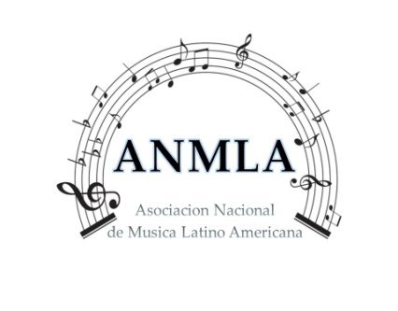
“ PHOTO, LECTURE VIDEOTAPE PERMISSION TO USE”
“FOR POSTING TO A PUBLIC SITE ”
I hereby grant A.N.M.L.A. permission to record, photograph and distribute via an openly accessible website
And/or other electronic formats for educational purposes, my photo`s and videotape`s. this grant includes
Rights for internal, external use for educational purposes and includes authorization to use my name, voice,
Likeness, biographic information, and supporting material in connection with each recorded class.
A.N.M.L.A. will not use the capture content for any other purpose without obtaining permission from
The undersigned. I understand that the A.N.M.L.A. will act in reliance on this permission.

To my knowledge my videotapes, photo material fall within fair use guidelines. Acceptable
Media usage, according to fair use guidelines:
.Showing a few Photos, Videotapes, articles or website
.Playing short portions of movies for informational purposes
.Displaying quotes from journal articles or stories
( STUDENT) PRINT NAME :___________________________________________________________
SIGNATURE :____________________________________________________________________

PARENT NAME :_____________________________________________ PHONE :_____________________________
PARENT SIGNATURE :_____________________________________________ DATE : _______________________
E-mail :__________________________________________________

